The Container Registry is the place to store images built and pushed from Docker

Open Azure, type in the search bar and select Container registry

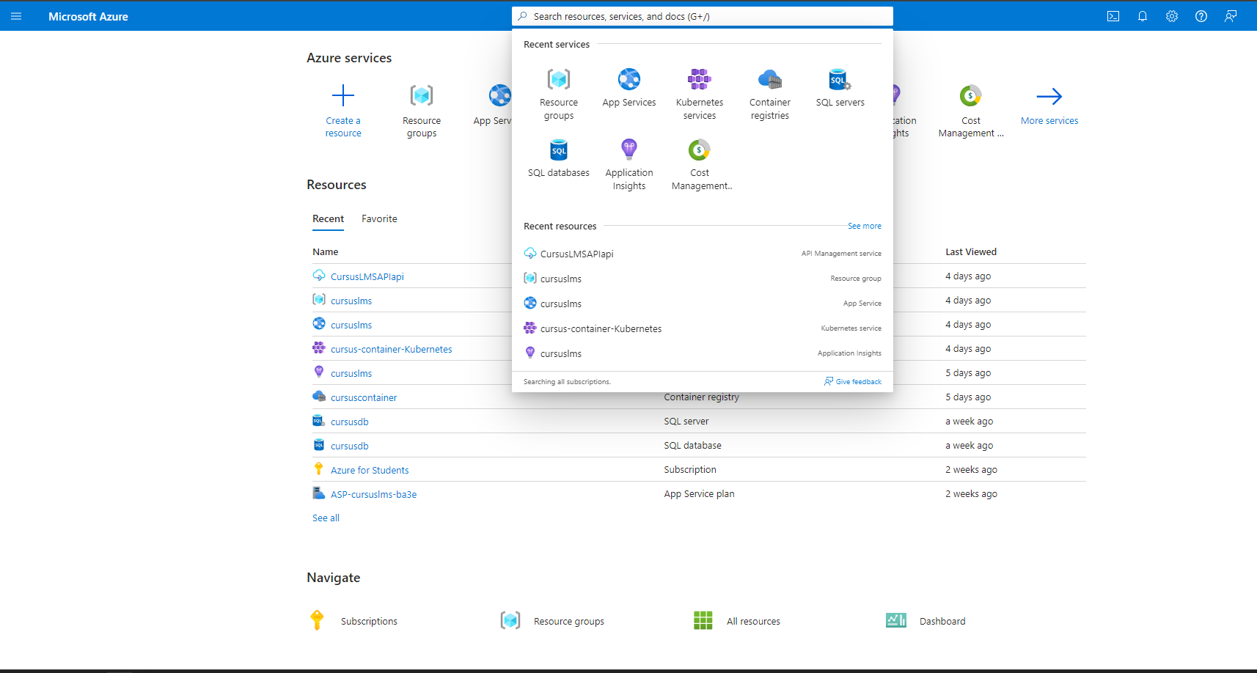

Select create

Select the created Resource group

Name the registry and select the appropriate location and price, and finally click Preview + create

The container has been created successfully

These are images that have been built and pushed from Docker, saved in the Repository section

